n8n Workflow
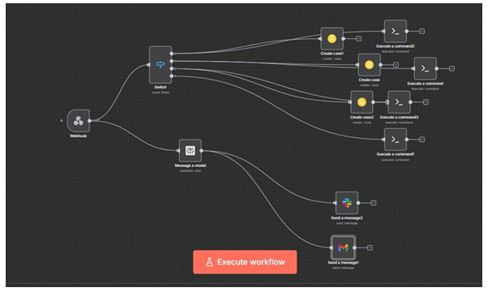

- The webhook gets the information when the alerts are triggered in splunk .
- The information received by webhook is sent to perplexity node that makes a report and send it to slack and gmail.
- Simultaneously the data is sent to Jira for assigning the task to different level of SOC analyst based on the severity of the alert.
- The ssh node are triggered based on the type of alert triggered in splunk to control the threat and respond to it as soon as possible.
- The ssh node response is not the final response ,it is a quick response to control the threat so that the analyst can take proper action in due time.

